Query with Joins – Equi Join, Inner Join, Outer Join

AIM: To perform JOIN using Equi Join, Inner Join, Outer Join on the given relation.
DESCRIPTION:
JOIN
A MySQL join is a method of linking data from one or more tables based on values of the common column between tables.
MySQL supports the following types of joins:
- Cross join
- Inner join
- Left join
- Right join

CROSS JOIN
The CROSS JOIN makes a Cartesian product of rows from multiple tables. Suppose, you join t1 and t2 tables using the CROSS JOIN, the result set will include the combinations of rows from the t1 table with the rows in the t2 table.

INNER JOIN
To join two tables, the INNER JOIN compares each row in the first table with each row in the second table to find pairs of rows that satisfy the join-predicate. Whenever the join-predicate is satisfied by matching non-NULL values, column values for each matched pair of rows of the two tables are included in the result set.
LEFT JOIN
Unlike an INNER JOIN, a LEFT JOIN returns all rows in the left table including rows that satisfy the join-predicate and rows that do not match. For the rows that do not match the join-predicate, NULLs appear in the columns of the right table in the result set.

RIGHT JOIN
A RIGHT JOIN is similar to the LEFT JOIN except that the treatment of tables is reversed. With a RIGHT JOIN, every row from the right table (t2) will appear in the result set. For the rows in the right table that do not have the matching rows in the left table (t1), NULL appears for columns in the left table (t1).

STEP 3 — Create a second table:
We will create a table called juice_prices.
It will store the price of each juice.
Run:
CREATE TABLE juice_prices (
juice_name VARCHAR(30),
price INT
);

STEP 4 — Insert data into juice_prices
Run:
INSERT INTO juice_prices
(juice_name, price)
VALUES
('Orange', 80),
('Banana', 50),
('Mango', 70),
('Apple', 60),
('Watermelon', 90);

STEP 5 — View the second table
Run:
SELECT * FROM juice_prices;

QUESTION 1 — EQUI JOIN

Display the customer name, juice name, number of juices and price by joining juiceshopc and juice_prices.
An Equi Join uses an equality condition such as:
table1.column = table2.column
Run:
SELECT
j.customer_name,
j.juice_name,
j.no_of_juices,
p.price
FROM juiceshopc AS j
JOIN juice_prices AS p
ON j.juice_name = p.juice_name;

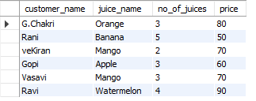

QUESTION 2 — INNER JOIN

Display all customers and the price of their purchased juice using INNER JOIN.
Run:
SELECT
j.customer_name,
j.token_no,
j.juice_name,
p.price
FROM juiceshopc AS j
INNER JOIN juice_prices AS p
ON j.juice_name = p.juice_name;
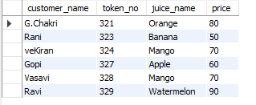

QUESTION 3 — LEFT JOIN

Display all customers from juiceshopc and their corresponding juice prices.
Run:
SELECT
j.customer_name,
j.juice_name,
p.price
FROM juiceshopc AS j
LEFT JOIN juice_prices AS p
ON j.juice_name = p.juice_name;
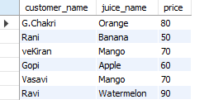
STEP 4 — RIGHT JOIN
For the outer join part, we can also demonstrate a RIGHT JOIN.
QUESTION 4
Display all juice prices and the customers who purchased those juices.
Run:
SELECT
p.juice_name,
p.price,
j.customer_name
FROM juiceshopc AS j
RIGHT JOIN juice_prices AS p
ON j.juice_name = p.juice_name;
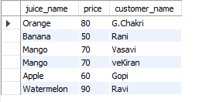
RESULT
The JOIN operations were successfully performed using Equi Join, Inner Join, Left Join and Right Join on the related juiceshopc and juice_prices tables. This follows the Join concepts specified in Experiment 9 of your lab manual

